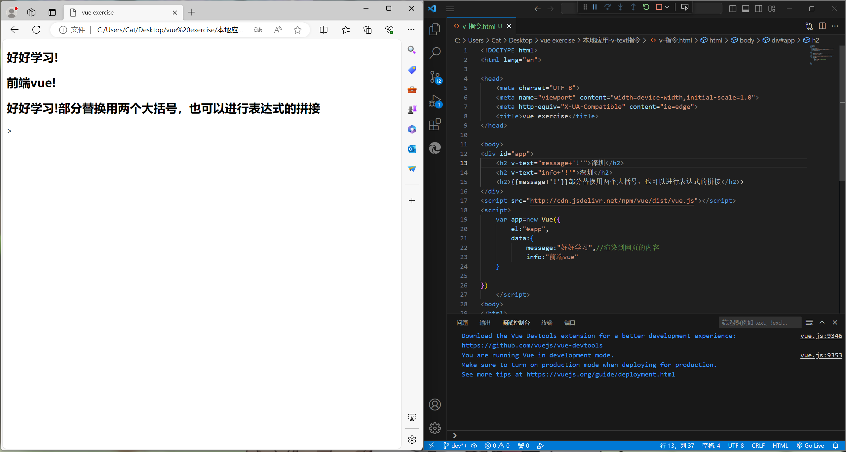

<!DOCTYPE html>

<html lang="en">

<head>

    <meta charset="UTF-8">

    <meta name="viewport" content="width=device-width,initial-scale=1.0">

    <meta http-equiv="X-UA-Compatible" content="ie=edge">

    <title>vue exercise</title>

</head>

<body>

<div id="app">

    <h2 v-text="message+'!'">深圳</h2>

    <h2 v-text="info+'!'">深圳</h2>

    <h2>{{message+'!'}}部分替换用两个大括号，也可以进行表达式的拼接</h2>>

</div>

<script src="http://cdn.jsdelivr.net/npm/vue/dist/vue.js"></script>

<script>

    var app=new Vue({

        el:"#app",

        data:{

            message:"好好学习",//渲染到网页的内容

            info:"前端vue"

    }

})

    </script>

<body>

</html>